MACH4METAL

metalworking machinery
Transito 21,
6909 DA BABBERICH, Netherlands
Tel. + 31 (0)316 – 247123
Fax. + 31 (0)316 - 247956
info@mach4metal.com
www.mach4metal.com

Bank No : 66.52.13.883
IBAN : NL33 INGB 0665 2138 83
BIC : INGBNL2A

Elumatec DG 79 double mitre saw
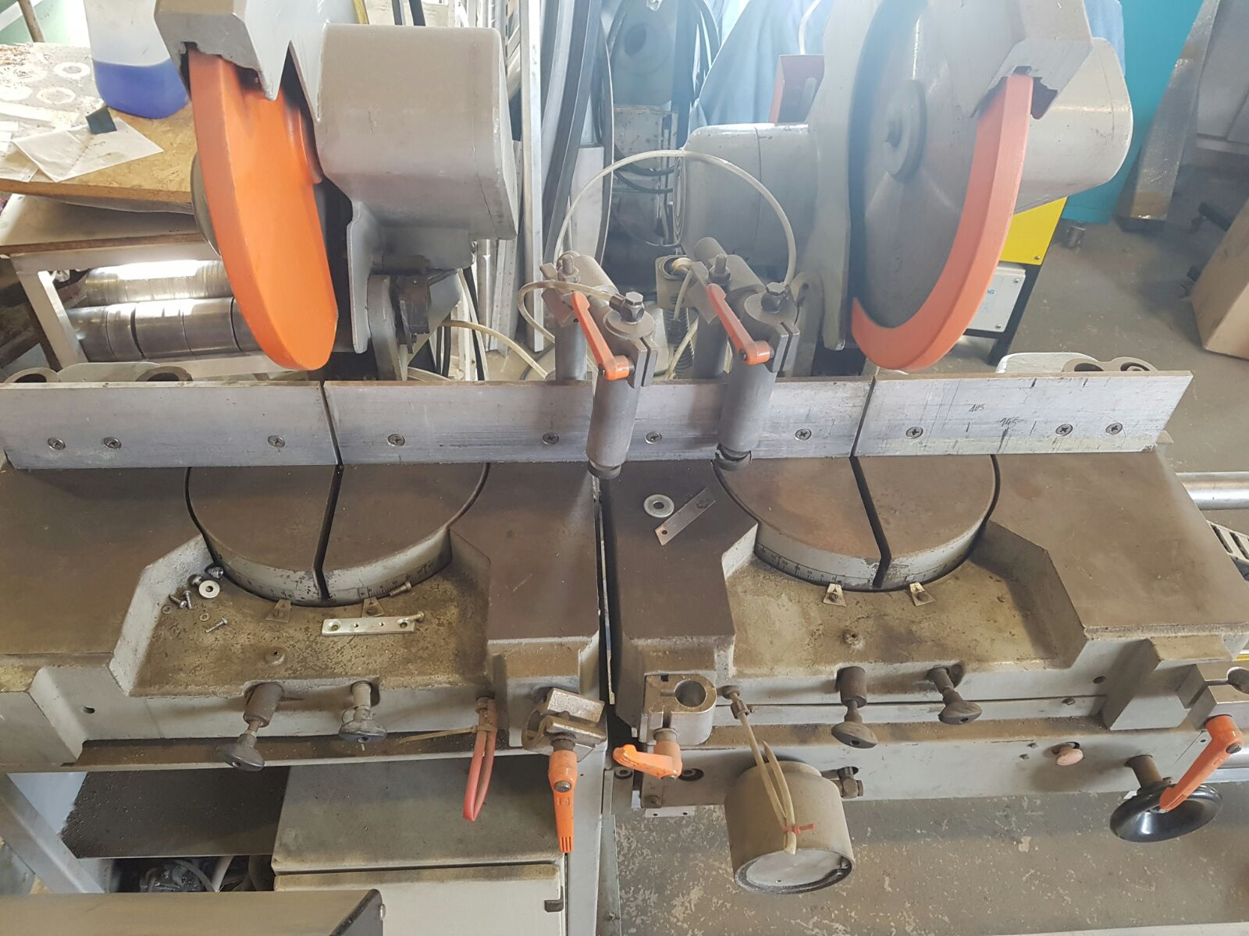

- Make : Elumatec Germany
- Typ : DG 79
- No : 30 291
- Age : 04 / 1991

- Saw blade Ø : 380
- Saw blade bore : 32
- Blade speed 1 : 2.800
- Blade speed 2 : 3.800
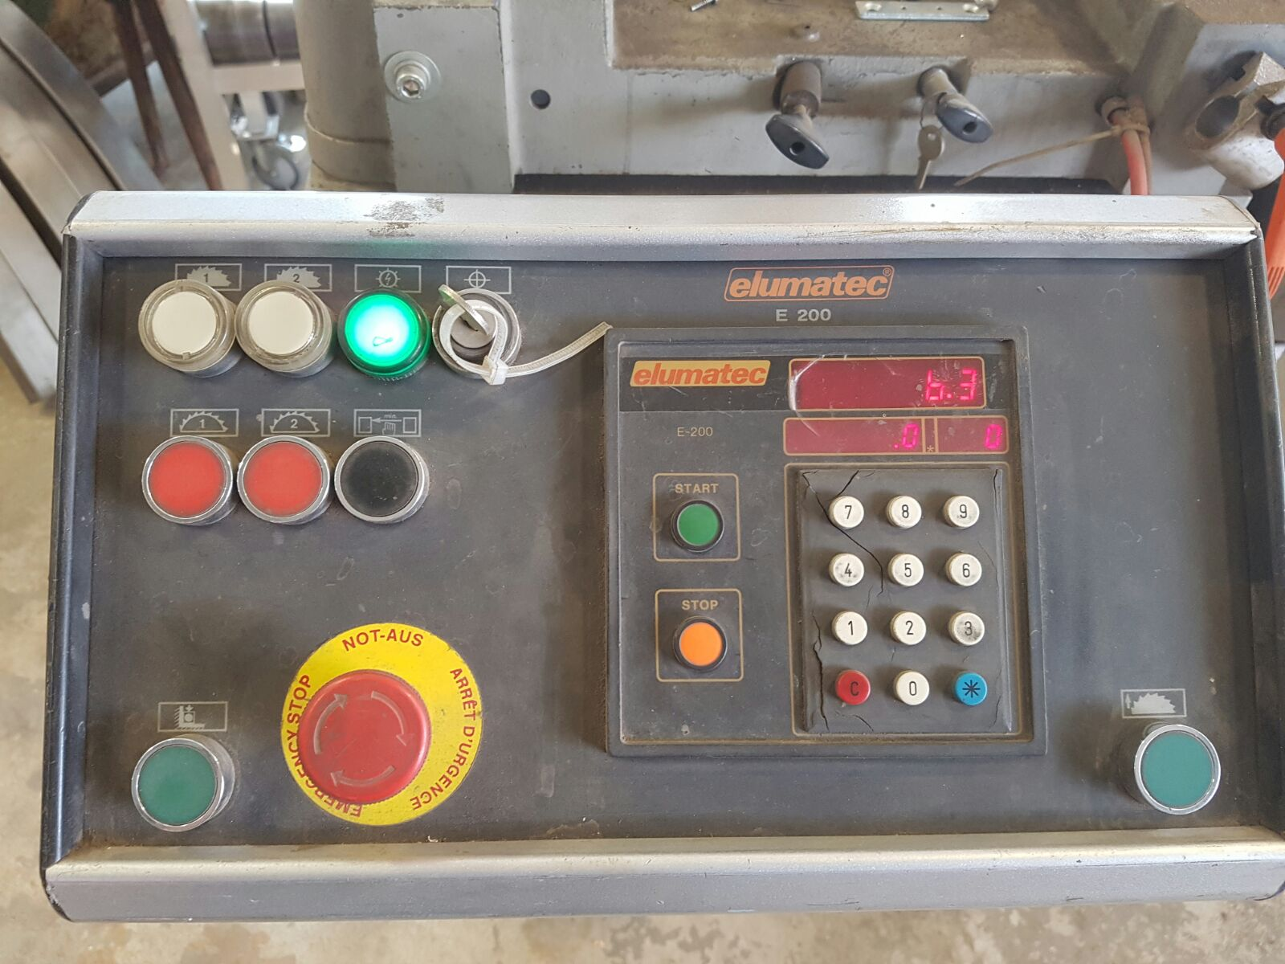
- Swivel range Left : 15 / 22,5 / 30 / 45
- Swivel range Right: 15 / 22,5 / 30 / 45
- Cutting angle : 0 - 45°

- Smallet cutting length : 500
- Longest cutting length : 3.000

- Drive power : 2 x 3000 W
- Air connection : 7 Bar

- Dimensions
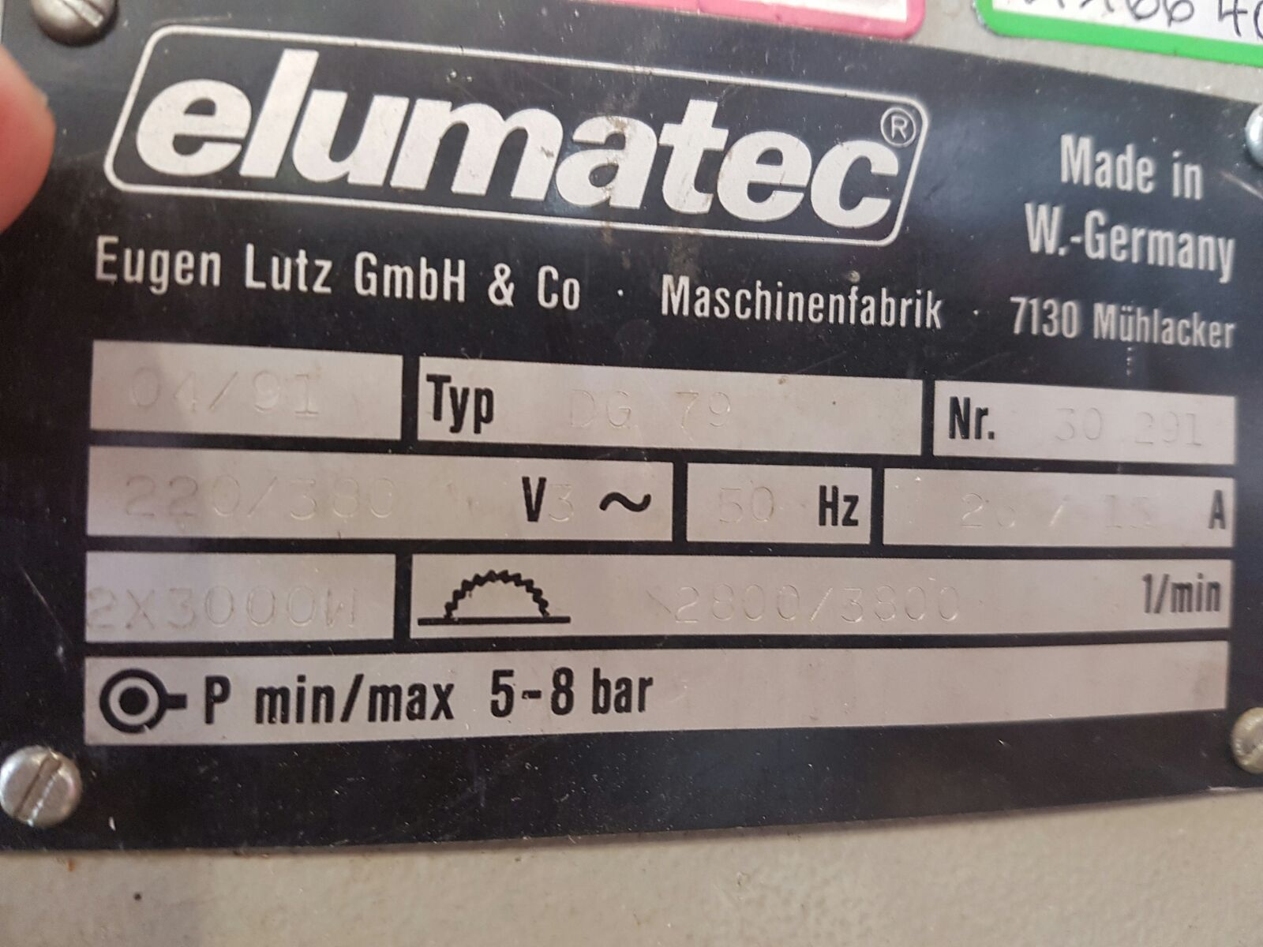
- Length : 4.100
- Width : 1.400
- Height : 1.800
- Weight :

Please Note: The above information has been obtained to the best of our ability and belief from, and from the manufacturers where possible. It is given in good faith, but its accuracy can not be guaranteed. Accordingly, it will not form a representation or constitute contractual terms. We advise you to check any vital details!

